Iqueue Project

Wireframes

Software Engineering for Automation (2022-2023)

DA CAMBIARE METTENDO PIU’ COERENTE RISPETTO IL NOSTRO

*Wireframes* helps to create some mock-ups that show an example of suitable user interface of our Iqueue project.

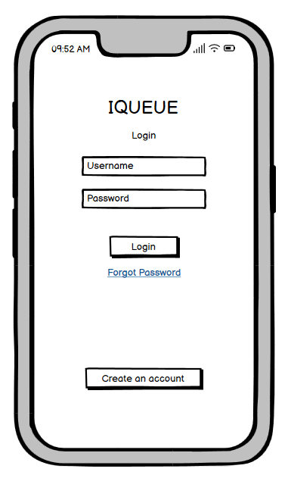

Figure 1: Wireframe of the initial page of the system

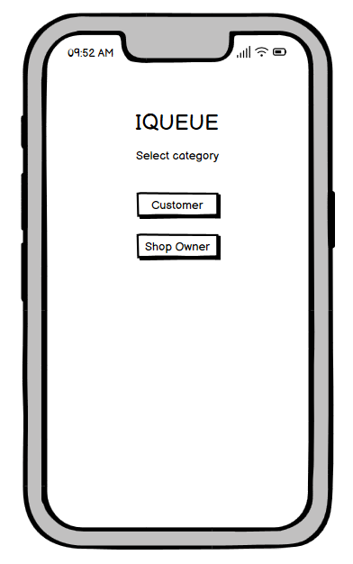

Figure 2: Wireframe of the page in which the user selects whether to act as a customer or a shop owner

Figure 3: Wireframe of the page that allows the customer to select the shop category he wants to visit

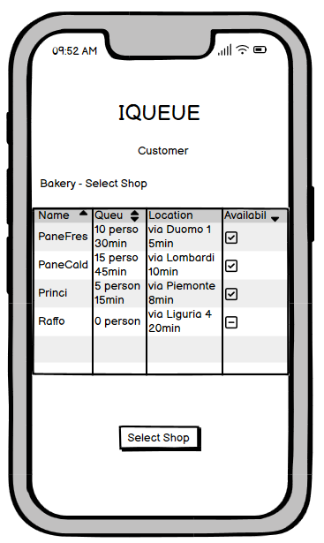

Figure 4: Wireframe of the page that allows the customer to select the shop he wants to go, given the category chosen before, the number of people in queue at the shop in that moment, the waiting time in that moment, the location, the time needed to reach the place and the availability of the shop

Figure 5: Wireframe of the page that allows the customer to select the date he wants to go to the previously selected shop.

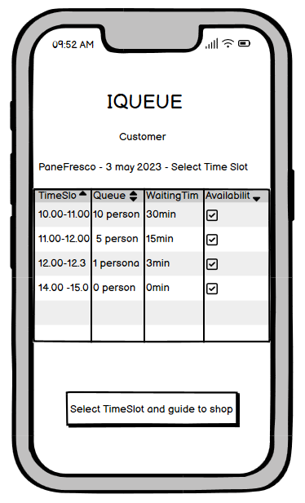

Figure 6: Wireframe of the page that allows the customer to select the time slot to go to the selected shop. Once pushed the button the Iqueue app will open the GPS system to guide the customer to the desired location.

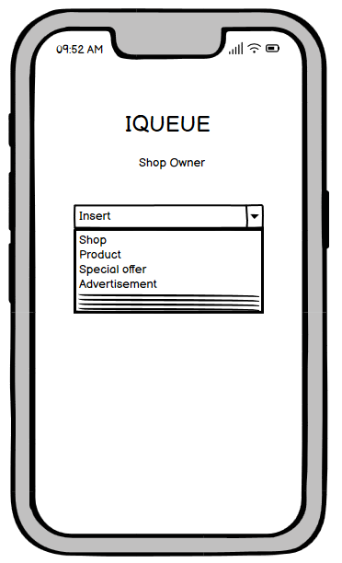

Figure 7: Wireframe of the page that allows the Shop Owner to choose what type of information insert into the Iqueue app. The possible choices could be: Shop, Product, Special offer, Advertisement.

Figure 8: Wireframe of the page that allows the Shop Owner to insert the shop data

Figure 9: Wireframe of the page that allows the Shop Owner to insert the shop product data.